**Manual Calculation of DL**

In part one of the deep learning calculation, we start by calculating the gradients for the output layer weights using this equation: 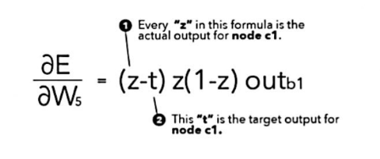

Using the equation, I was able to calculate weights 5, 6, 7, and 8.

Part 2: In part two of the deep learning calculation process, we would calculate the gradients for the output layer bias weights

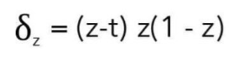

We were able to calculate bias weights 3, 4, and 2

Part 3: calculating gradients for hidden layer weights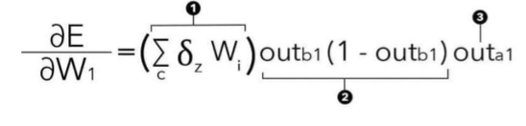

This equation is a summary of the previous equations that we have calculated. Doing this portion of the calculation process is easy.

Part 4: calculating gradients for hidden layer bias weights.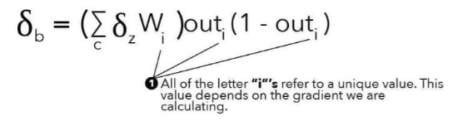

Part 5: The final step in backpropagation is updating the weights

